Lab 4 – Manchester Coding

# Youssef Samwel

# [yo800238@ucf.edu](mailto:yo800238@ucf.edu)

# EEL4515 Fundamental of Digital Communications

Prof. Dr. George Atia - Section 0012

# 2/29/2024



# **Experiment Objective**

The purpose of this experiment is to be familiarized with the basics of line coding, i.e., mapping bits to pulses. We focus on Manchester coding in generation using MATLAB and observing the spectrum of the Manchester encoded signal on the spectrum analyzer.

# **2.0 About Laboratory Day and Equipment List**

# The laboratory session took place on the Thursday section between 9:00am and 11:50am on February 29th, 2024. My lab partner was Isiah. The equipment for the is experiment is listed below,

1. MATLAB
2. Rohde & Schwarz RTM 3034 Oscilloscope
3. Spectrum Analyzer
4. Function Generator

# **3.0 Simulation**

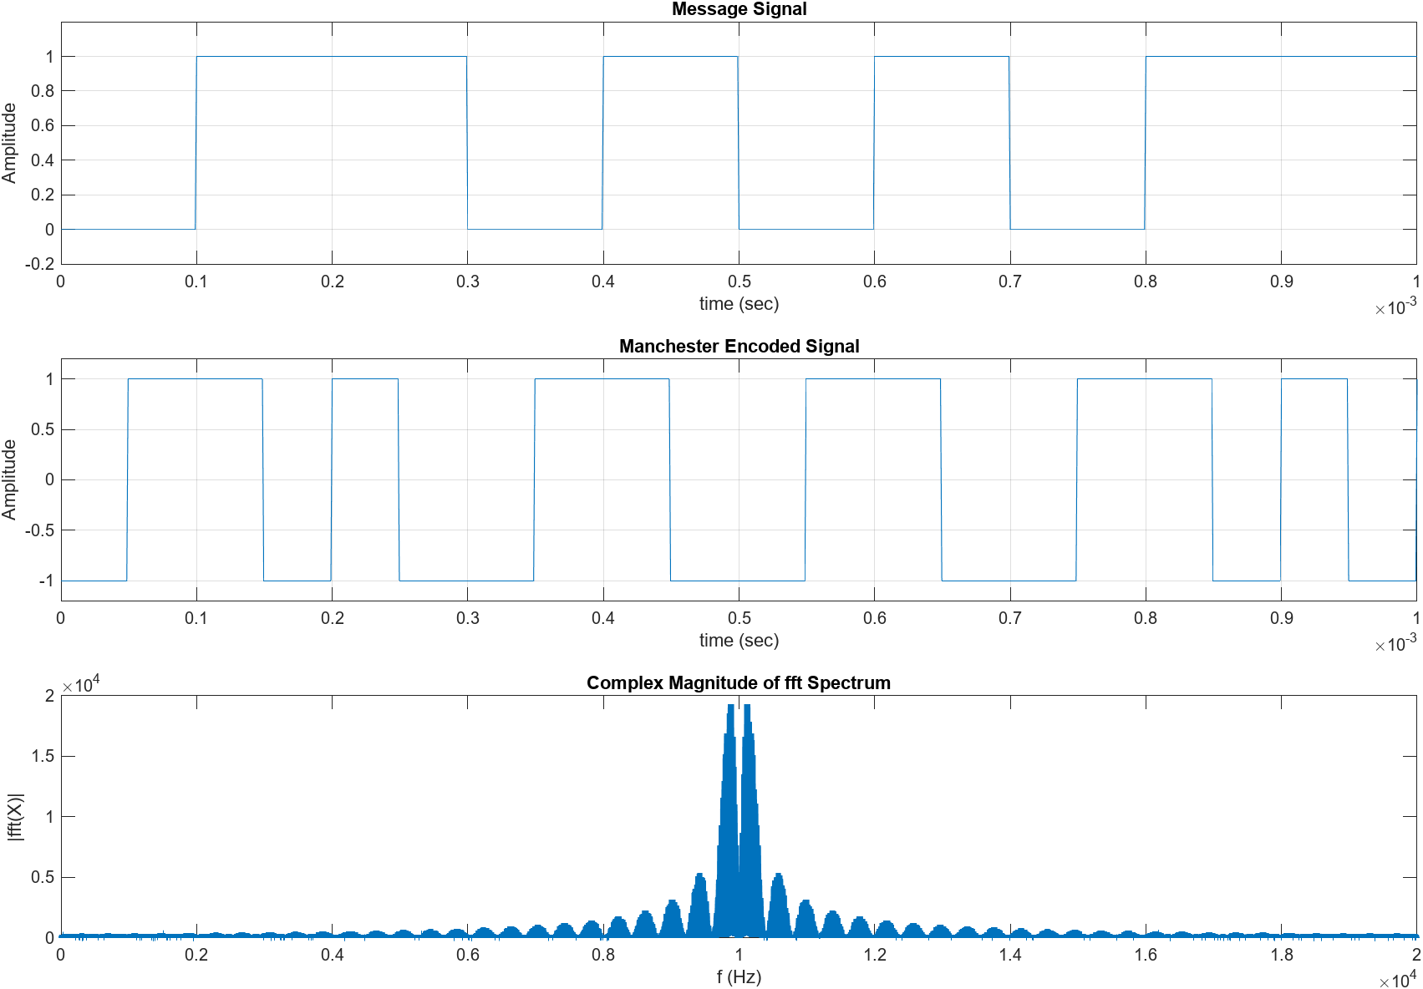

Manchester Encoding Simulation Results

See Section 5.0 for MATLAB code.

# **4.0 Implementation**

The function generator can generate arbitrary signals using the DAC given the signal samples. Using the sampled signal from the simulation, we were able to encode an arbitrary signal file for the function generator. The following is a screenshot of the sampled signal.

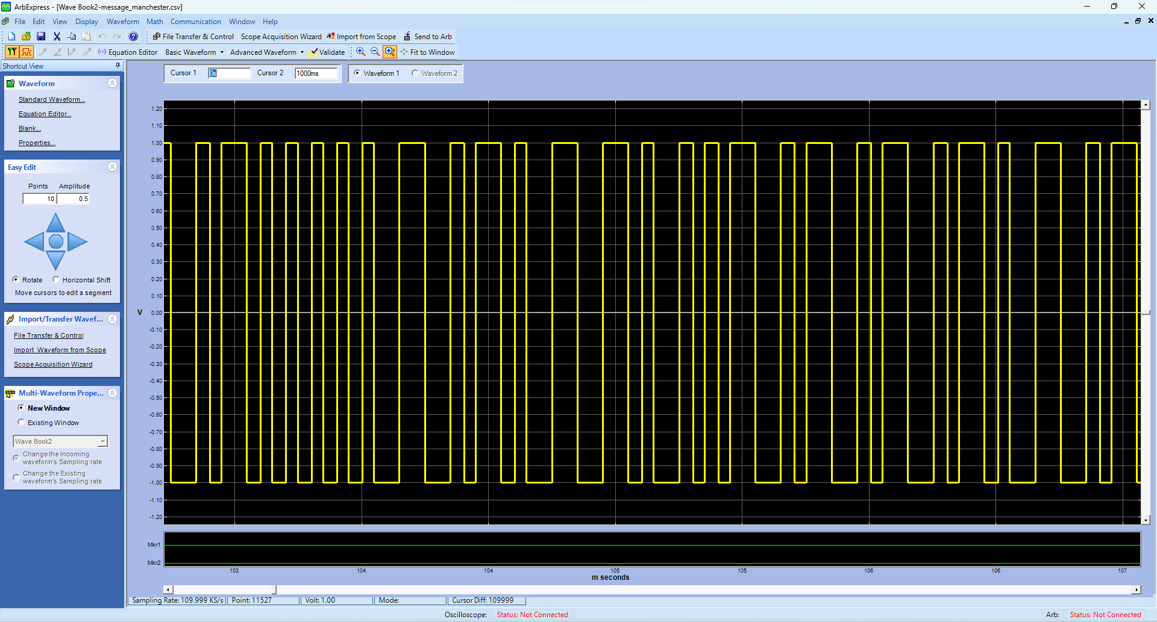

ArbExpress Conversion from CSV Format

Measured Manchester Encoded Signal on Oscilloscope (Time Domain)

Frequency Spectrum of Encoded Signal

# **4.5 Questions and Results**

1. Compare Manchester coding to other line coding schemes studied in the lectures.

Manchester coding has no DC component which is necessary for communication systems that require AC coupling (AC coupling would block the DC signal). Both polar and on-off coding have a DC component. However, Manchester coding is less power efficient compared to polar coding; Manchester coding requires twice the power compared to polar coding for the same noise immunity.

2. Compute the power spectral density of the Manchester coded signal and verify it theoretically.

The theoretical PSD can be computed using this equation:

3. What assumption(s) should be satisfied to ideally verify the PSD calculations?

The signal should be random, and the sample period should be wide enough to accurately represent the signal. The signal should be infinite.

# **5.0 MATLAB Code**

Used to generate figure(s)

clear

close all

clc

% Set the length of the binary signal

signalLength = 10000;

% Generate a random binary signal

binarySignal = randi([0 1], 1, signalLength);

PulseWidth = 1000e-3; % 100 ms

time_step = 10e-3; % 10 ms

x = zeros(signalLength * (PulseWidth / time_step), 1);

x2 = x;

j = 1;

for i=1:1:signalLength

for t = 0:time_step:PulseWidth

x(j) = binarySignal(i);

if binarySignal(i) == 1

if t >= PulseWidth / 2

x2(j) = -1;

else

x2(j) = 1;

end

else

if t >= PulseWidth / 2

x2(j) = 1;

else

x2(j) = -1;

end

end

j = j + 1;

end

end

%time = linspace(0, (PulseWidth) * signalLength, length(x));

time = linspace(0, 1, length(x));

subplot(3, 1, 1);

plot(time, x);

xlim([0, 10/signalLength]);

ylim([-.2, 1.2]);

title("Message Signal");

xlabel("time (sec)");

ylabel("Amplitude");

grid on;

subplot(3, 1, 2);

plot(time, x2);

xlim([0, 10/signalLength]);

ylim([-1.2, 1.2]);

title("Manchester Encoded Signal");

xlabel("time (sec)");

ylabel("Amplitude");

grid on;

data = [transpose(time), x2];

%writematrix(data, 'message_manchester.csv');

Fs = (2*signalLength); % Sampling frequency

T = 1; % Sampling period

L = length(x2); % Length of signal

t = (0:L-1)*T; % Time vector

M = fftshift(fft(x2));

subplot(3, 1, 3);

plot(Fs/L*(0:L-1),abs(M),"LineWidth",3)

title("Complex Magnitude of fft Spectrum")

xlabel("f (Hz)")

ylabel("|fft(X)|")

# **6.0 Learned Objectives**

* Arbitrary Signal Generation
* Manchester Encoding
* MATLAB Simulation

# **7.0 Conclusion**

In conclusion, the PCM experiment on Manchester coding enhanced our understanding of line coding fundamentals. Through MATLAB simulation and practical implementation, we successfully encoded signals, observed them on oscilloscope and spectrum analyzer, and compared Manchester coding with other schemes. Theoretical verification of power spectral density was explored, emphasizing key assumptions. The MATLAB code demonstrated the process effectively. Overall, the experiment achieved its objectives, offering hands-on experience in digital communication concepts.